**VIRTUALEYE - LIFE GUARD FOR SWIMMING POOLS TO DETECT ACTIVE DROWNING**

**1. INTRODUCTION**

**1.1 Project Overview**

Every year, many individuals, including kids under the age of 5 drown in the deeps of the Eswimming pool, and the lifeguards are not well trained enough to handle these situations. Thus arises the requirement for having a system that will consequently detect the drowning individuals and alarm the life guard at such risk. Swimming pool surveillance systems plays an essential role in safeguarding the premises. In this project differential pressure approach is used for detection ofdrowning incidents in swimming pools at the earliest possible stage. The children’s life is saved during drowning incidentsin the swimming pool by lifting the acrylicplate. The proposed approach consists of RF module, Pressure Sensor and Motor Driver. The demo systembased on pressuresensor has an advantage of convenience, cost saving and simple algorithm.

**1.2 Purpose**

Swimming is a kid’s favorite aquatic sport and it’s a great stress buster. But in the water, beginners often feel hard to breathe which causes choking actions, loss of balance and results in a drowning accident. Some special circumstances, such as cramps, collide with each other, disease or mental stress and so on may also cause swimmer to drown. Drowning is a leading cause of death and disability for children. Worldwide, drowning produces a higher mortality rate than any other cause of injury in children less than 15 years of age [3].

**2. LITERATURE SURVEY**

**2.1 Existing problem**

**POSEIDON- Video based drowning detection system in the swimming pool**

Swimmingpool drowning monitoring system based on video technology is mostly reported in the literature. There are three kinds drowning monitoring system according to the different position of the camera. One is that the camera is mounted on the underwater swimmingpool wall, then monitor underwater swimmer status. A limitation of this equipment is that iftoo many swimmers, the occlusion problem arises. The other is that the camera is mounted upon the water,and monitors the Swimmer posture change.The reflection and refraction of light in air-water interference will affect the image quality, and drowning man feature this method detected is not easy to distinguish swimmers and diversobviously. The thirdis a combination of the two, underwater camera and aerial camera matched, monitoring the swimmerposture. This system needs constantobservation which is the main disadvantage.

## Wearable devices for early monitoringand alarming for drowning incidents

The wearable drowning monitor device can detect drowning accident and alarm. The device has seven main modules, including microprocessor, power module, SD memory card module, LED warning module, acceleration sensor module, water pressure sensor module, and keys module. When swimming the human arm must constantly waving in the water, if drowning, arm motion of floating is significantly reduced, and if falling into the water, almost motionless. According to the physiological response of human drowning, it can detect drowning accident by recording arm motion real-timethrough wearable wrist accelerometer device. This accelerometer is packed with embedded functionswith edible user programmable options,configurable to two interrupt pins. The pressure sensor is installed to judge whether the human body is in the water. The red LED is used for drowningwarning. One blue LED is used to get the work status of the device which wills flash every few seconds in order to save the precious energy.Because LED light- emittingangle generally relatively small, 5 red LED lightsof upward and around direction is installed to make LED alarm signal caller. Two keys are designedfor the demo device

One is the switch for power.The other is a self-help button. If drowningdanger occurs, the swimmer can push the button and the blue LED will shine for help, and if a swimmer accidentally hit the button,he can push the buttonto cancel the alarm. If the swimmer lost consciousness because of drowning,the device detects the drowning accident and willON LED light to informthe lifeguard.

The device is worn on the wrist and move in large amplitude along with the wrist when a human is swimming in the water, and the data acquired from accelerator will dramatically change. If a human is drowning in water, his or her wrist almost motionless, and the data acquired from accelerator will have only small changesdue to water movement.The drowning detection methoduses threshold. First, data from a water pressure sensor is used to judge whether the human body in the water, if the body in the water, then start drowningjudgment process. Then, analog signal obtained from the three axis acceleration sensor is convertedto digital signal and three axis acceleration values are gained. Hanningfiltering method and the moving average filtering are used to reducenoise error.

## LDR based automated drowning detection systemin the swimming pool

In the proposed method the human identification in the swimming pool depends on the LDR and laser. First, datafrom a water pressure sensor is used to judge whether the human body in the water,if the body in the water,then startdownloading judgment process.The iron metal plate is placed in the floor of the swimming pool. The laser and the LDR source are placed in the side of the wall. Here we are using an ATmega8l microcontroller to control the whole process. Embedded c language is used for the coding.Initially the laser source which spreads over the swimmingpool and the LDR which sense the laser light and which produces the resistance value. Depends on the resistance value the process has been taken.When the LDR value will be kept constantthen the alarm will be activated.The resistance value will be changed with respect to the human movement.The message will be sent to the administration by using the GSM service. After 30 seconds there is no change which means the plate will lift automatically using the motor and motor driver. The human has safe in this technique.

**2.2 References**

1. <https://www.linkedin.com/company/aqua-teik>
2. Journal of Computational Information Systems 9: 21 (2013) 8619{8627Available at [http://www.Jofcis.com](http://www.jofcis.com/)
3. International Journalof Innovative Researchin Computer and Communication Engineering (An ISO 3297: 2007 CertifiedOrganization) Vol. 3, Special Issue2, March 2015

**2.3 Problem Statement**

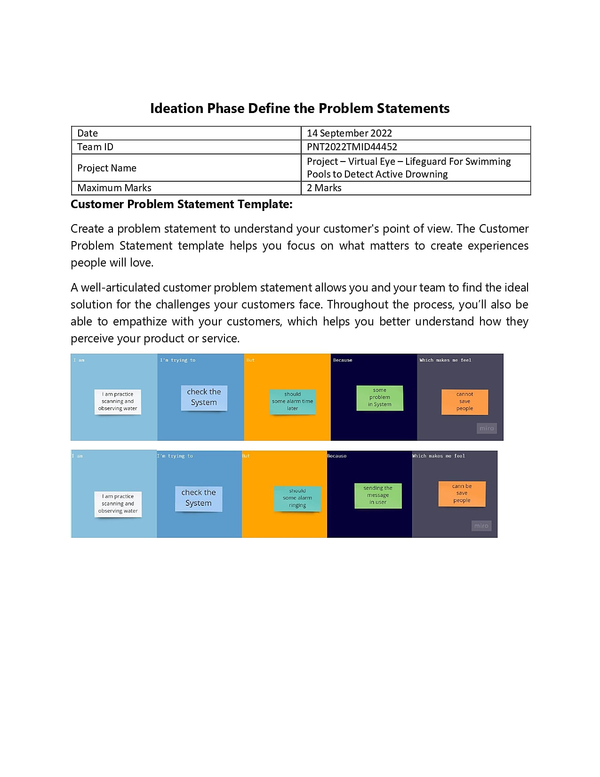

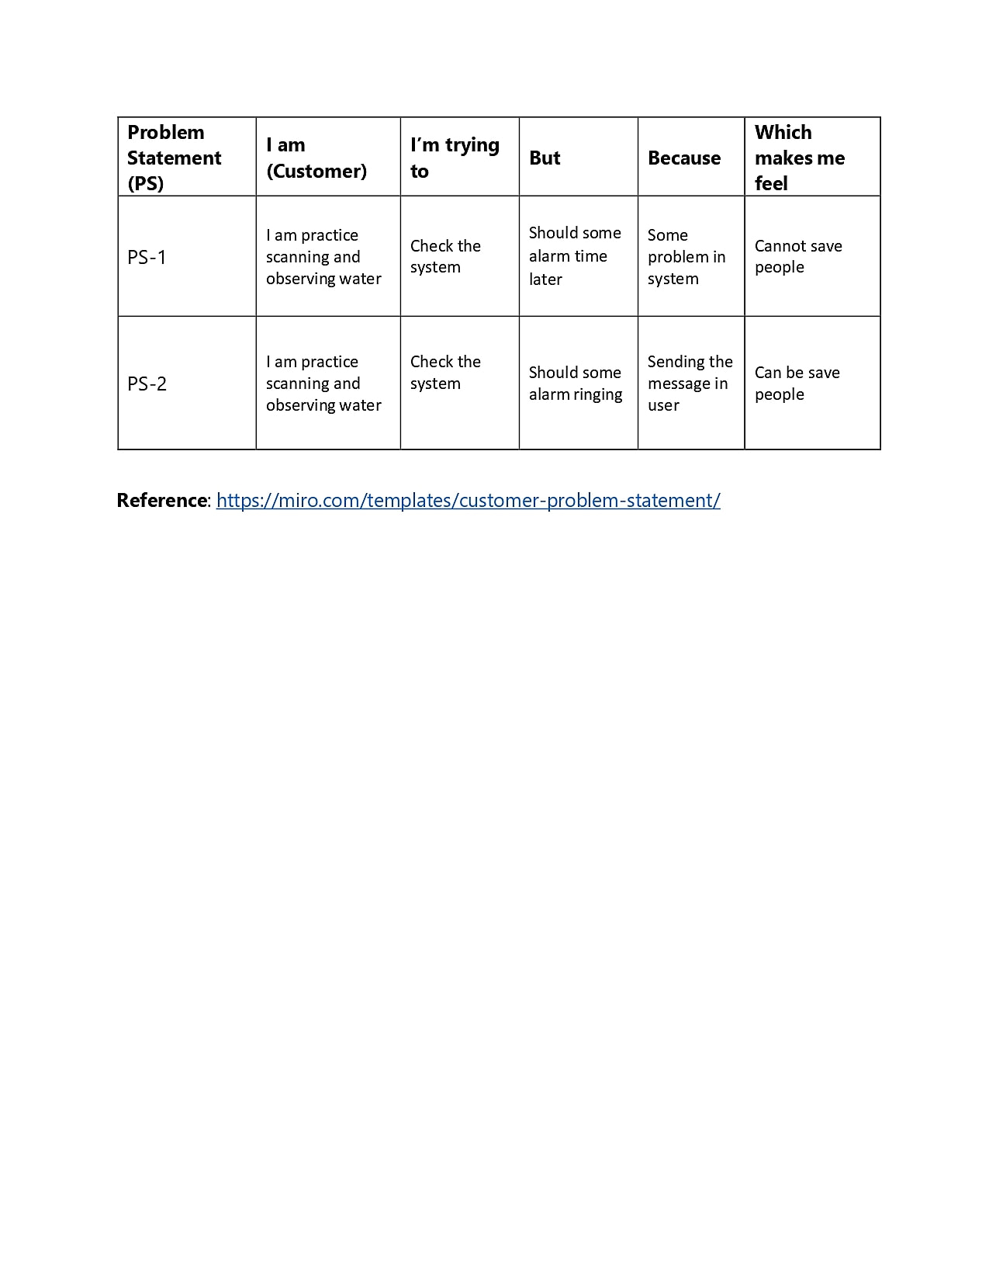

**3.IDEATION & PROPOSED SOLUTION**

**3.1 Empathy Map Canvas**

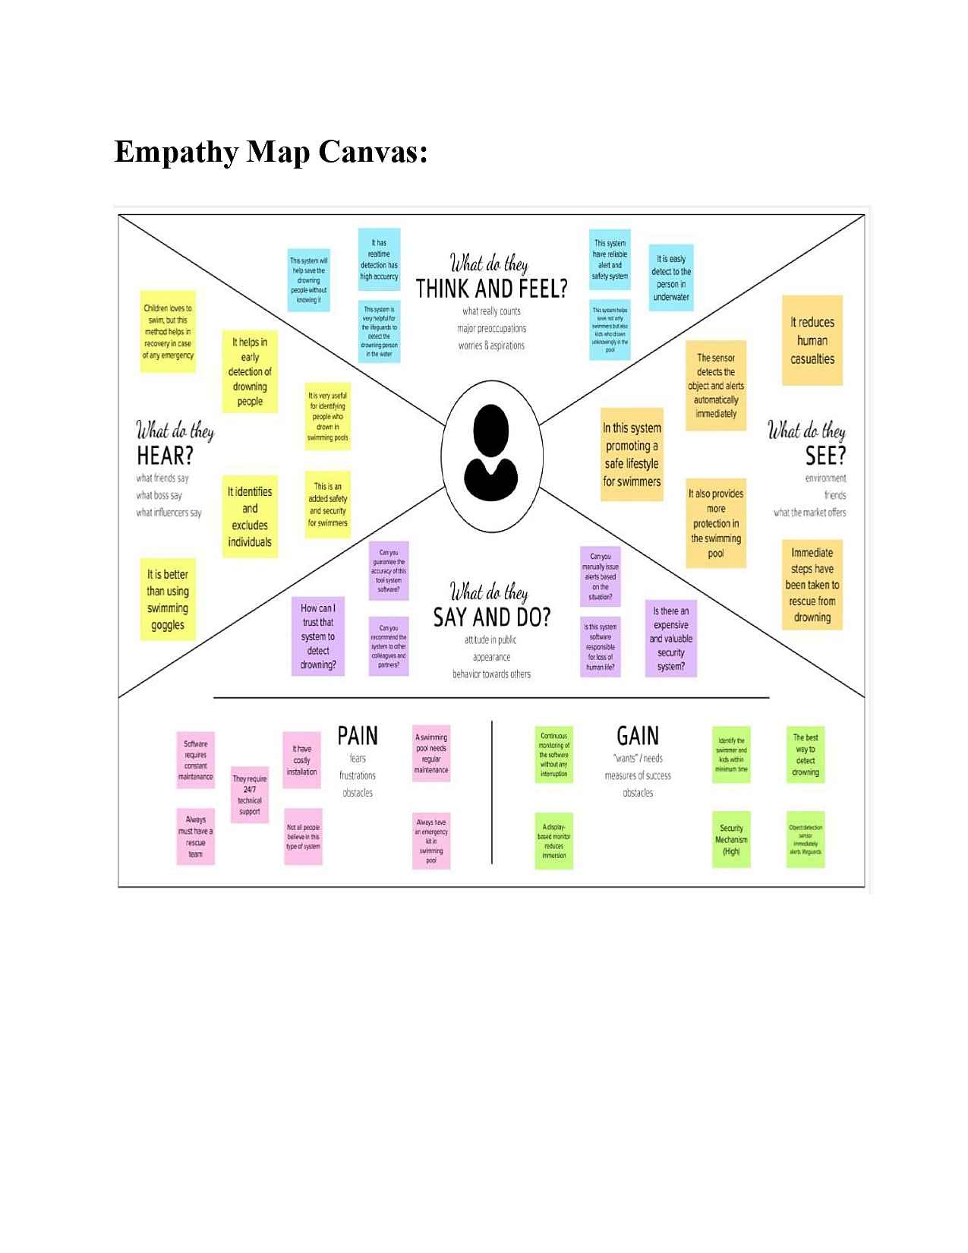

**3.2 Ideation and Brainstorming**

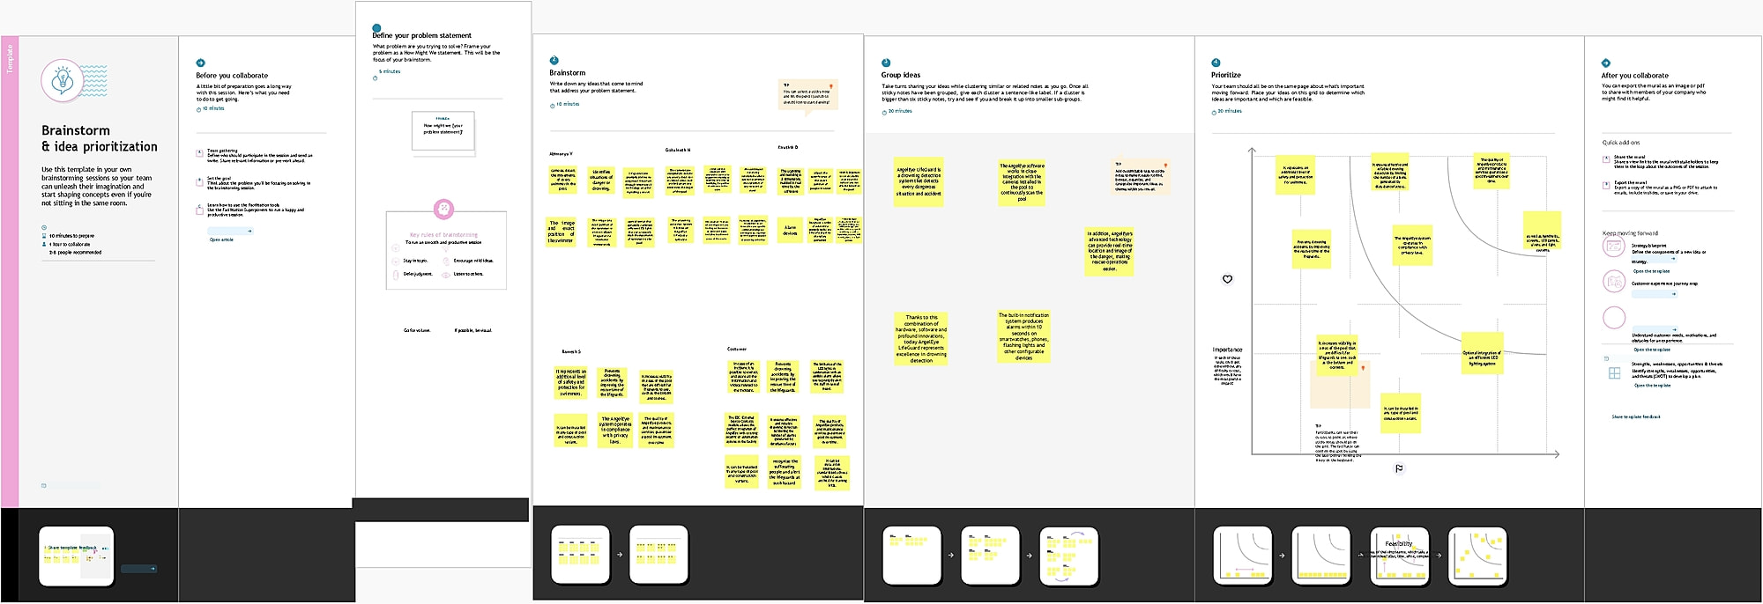

**3.3 Proposed Solution**

|  |  |  |
| --- | --- | --- |
| **S.No.** | **Parameter** | **Description** |
| 1. | Problem Statement (Problem to be solved) | VirtualEye - LifeGuard for Swimming PoolsTo Detect ActiveDrowning. |
| 2. | Idea / Solution description | Swimming is one of the best exercises that helps people to reduce stress in this urban lifestyle. Swimming pools are found larger in number in hotels, and weekend tourist spots and barely people have them in their house backyard. Beginners, especially, often feel it difficult to breathe underwater which causes breathing trouble which in turn causes a drowning accident so In This is project a Accurate Pulse Rate of every individual swimmer is also detected and sended as signal to the LifeGuard through alert message so it help LifeGuard to do earlier prediction of a swimmer pulserate is reducedor increased By  doing this they can get alert in advance and can savemore then one person from Drowning |
| 3. | Novelty / Uniqueness | Accurate pulserate detection usingDeep learning. |
| 4. | Social Impact/ Customer Satisfaction | In case of an incident it is possible to extract and storenot only the videos but also Pulse  rate of a victim so it willbe usefull to indentify the reason behindhis/her drowness. |
| 5. | Business Model(Revenue Model) | Can generate revenue from direct customers,like Lifeguard and collaborate with  maritime sectorand other swimming pool authorities. |
| 6. | Scalability of the Solution | Deep learning Algorithm for the Pulserate detection :  It helps the LifeGuard for earlier prediction of  drowning along withthe Reason behindhis/her drowning. |

**3.4 Problem Solution Fit**

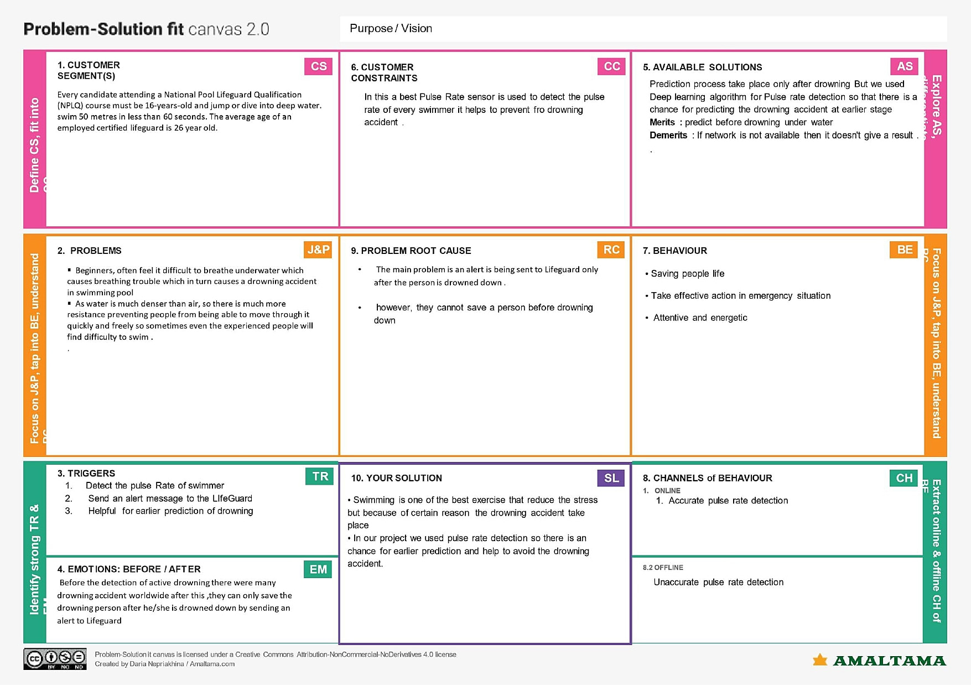

# 4.REQUIREMENT ANALYSIS

## 4.1 Functional requirements

Following are the functional requirements of the proposed solution.

|  |  |  |
| --- | --- | --- |
| **FR No.** | **Functional Requirement (Epic)** | **Sub Requirement (Story / Sub-Task)** |
| FR-1 | Camera from above | Images of drowning from above the pool. Videos of drowning from above the pool. |
| FR-2 | Under water camera | Images of drowning inside the pool. Videos of drowning inside the pool. |
| FR-3 | Software requirements | Windows 11 |
| FR-4 | Machine learning software | Pytorch, Keras, Tensorflow |
| FR-5 | Programming languages | Python, HTML, CSS |

## 4.2 Non Functional requirements

Following are the non-functional requirements of the proposed solution.

|  |  |  |
| --- | --- | --- |
| **FR No.** | **Non-Functional Requirement** | **Description** |
| NFR-1 | **Usability** | It can be used in public pools and swimming to alert the lifeguard indicating someone is drowning. |
| NFR-2 | **Security** | As the rescue is done as soon as the alert is on it can help in saving life. |
| NFR-3 | **Reliability** | It gives an extra pair of an eyes i.e., virtual eye to our lifeguard which helps him/her to detect drowning easily. |
| NFR-4 | **Performance** | It is faster than naked eyes which helps in rescue of the victim without missing the golden hour. |
| NFR-5 | **Availability** | It can be made available to swimming pool owners, and for public pools to avoid drowning. |
| NFR-6 | **Scalability** | As it uses images to identify movements The camera can have blind spots which will affect the performance of the system |

# 5.PROJECT DESIGN

## 5.1 Data Flow Diagrams

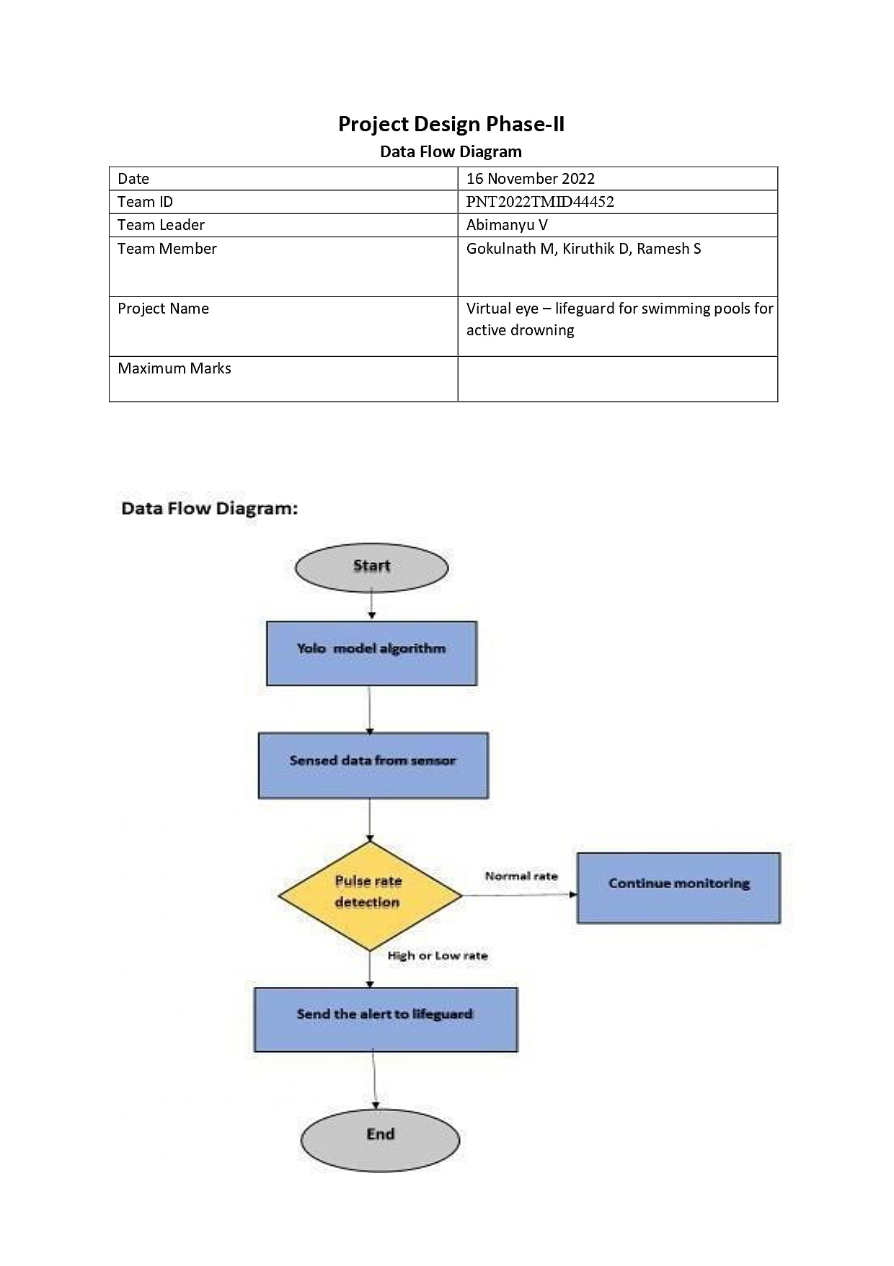

## 5.2 Solution and Technical Architecture

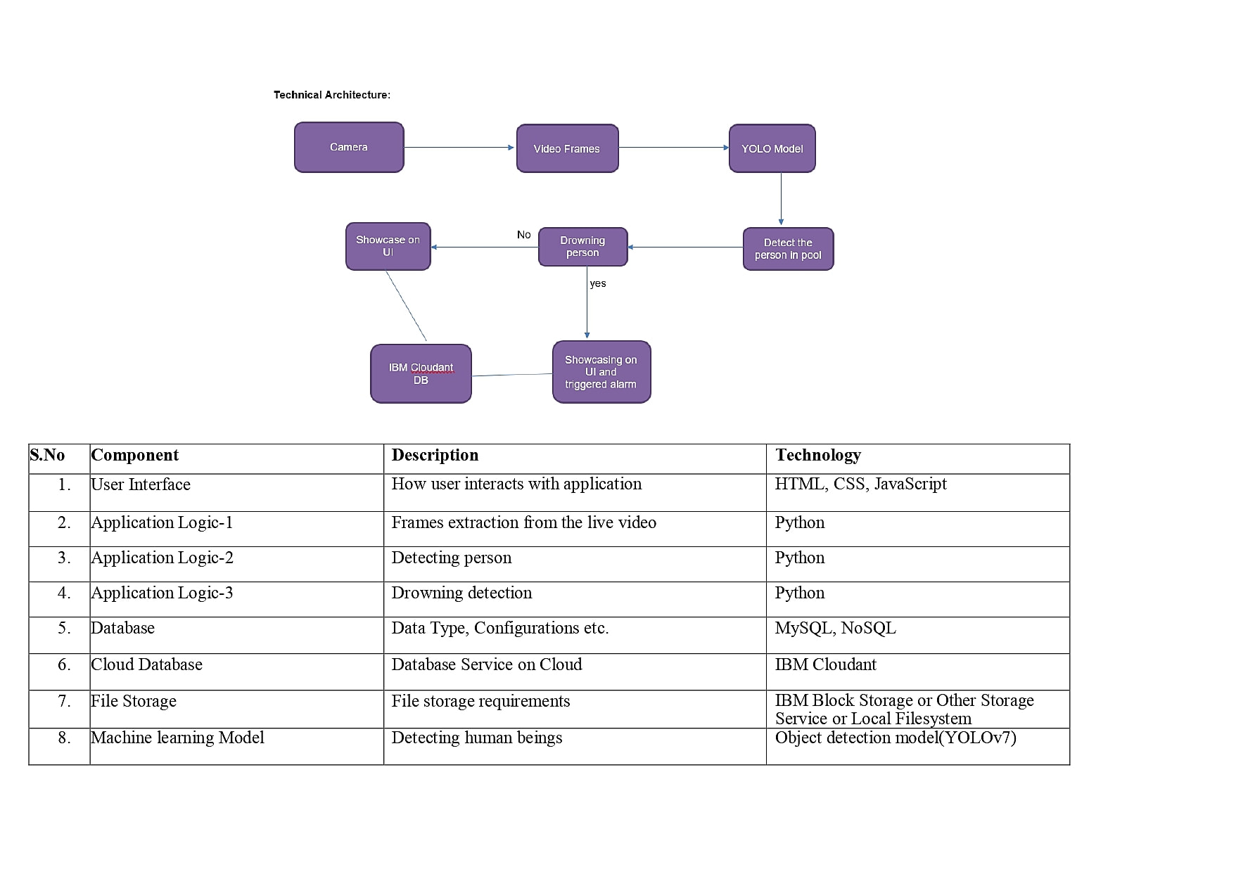

|  |  |  |  |
| --- | --- | --- | --- |
| **S.No** | **Component** | **Description** | **Technology** |
| 1. | User Interface | How user interacts with application | HTML, CSS, JavaScript |
| 2. | Application Logic-1 | Frames extraction from the live video | Python |
| 3. | Application Logic-2 | Detecting person | Python |
| 4. | Application Logic-3 | Drowning detection | Python |
| 5. | Database | Data Type, Configurations etc. | MySQL, NoSQL |
| 6. | Cloud Database | Database Service on Cloud | IBM Cloudant |
| 7. | File Storage | File storage requirements | IBM Block Storage or Other Storage Service or Local Filesystem |
| 8. | Machine learning Model | Detecting human beings | Object detection model(YOLOv7) |
| 9. | Infrastructure (Server / Cloud) | Application Deployment on Cloud | Cloud Foundry, Docker |

Table-2: Application Characteristics:

|  |  |  |  |
| --- | --- | --- | --- |
| **S.No** | **Characteristics** | **Description** | **Technology** |
| 1. | Open-Source Frameworks | Anaconda Navigator, Pytorch, Flask | Technology of Opensource framework |
| 2. | Security Implementations | Security and access control | IAM Controls |
| 3. | Scalable Architecture | Scalable architecture can load without compromising the application integruty | Microservices, Progressive web apps |
| 4. | Availability | Use of load balancers, distributed servers | IBM Cloud |
| 5. | Performance | Designing the system software that can monitor a wide range of swimming pool at a time without anny delay | IBM instance |

**5.3 User Stories**

Use the below template to list all the user stories for the product.

|  |  |  |  |  |  |  |  |
| --- | --- | --- | --- | --- | --- | --- | --- |
| **User Type** | **Functional**  **Requirement**  **(Epic)** |  | **User**  **Story**  **Number** | **User Story / Task** | **Acceptance criteria** | **Priority** | **Release** |
| Customer (pool owners) | Installation devices | of | USN-1 | As the owner of the pool I can install cameras on my pool and can set the drowning detection system. | I can connect the  camera to the database | High | Sprint-1 |
| Customer (Lifeguard) | Detecting drowning |  | USN-2 | As a user, I can detect if whether someone is drowning or not | I will receive an alert which notifies me. | High | Sprint-1 |
|  | Rescue |  | USN-3 | As a user, on receiving the alert I can | I can rescue the  drowning person | High | Sprint-1 |
|  |  | |  | rescue the drowning victim |  |  |  |
| Customer (Swimmer) | Safety | | USN-4 | As a user, I can swim without an worry. | I can swim with the assurance of the system  and the lifeguard | Medium | Sprint-2 |
| Customer  Care  Executive | Contact | | USN-5 | Technical issues are resolved | I can call the customer care executive to resolve the issues | Medium | Sprint-3 |
| Administrator | Dashboard | | USN-6 | Drowning detection system management and Database management | I can access all the data in the system anytime | High | Sprint-4 |

# 6.PROJECT PLANNING AND SCHEDULING

**6.1 Sprint Schedule and Estimation**

|  |  |  |  |  |  |  |
| --- | --- | --- | --- | --- | --- | --- |
| **Sprint** | **Functional**  **Requirement (Epic)** | **User Story Number** | **User Story / Task** | **Story Points** | **Priority** | **Team**  **Members** |
| Sprint-1 | Registration | VLGFSP-1 | As a user, I can register for the application by entering my email, password, and confirming my password. | 2 | High | Ramakrishnan |
| Sprint-1 | Registration | VLGFSP-2 | As a user, I will receive confirmation email once I have registered for the application | 1 | High | Ramesh |
| Sprint-1 | Registration | VLGFSP -3 | As a user, I can register for the application through Facebook | 2 | Low | Ramkumar |
| Sprint-1 | Registration | VLGFSP -4 | As a user, I can register for the application through Gmail | 2 | Medium | Nitheesh |
| Sprint-1 | Login | VLGFSP -6 | As a user, I can log into the application by entering email & password | 1 | High | Ramesh |
| Sprint-2 | Dataset Collect | VLGFSP -11 | Collect number of datasets and get accuracy | 2 | Medium | Ramkumar |
| Sprint-2 | Pre-processing | VLGFSP -12 | The dataset is extracted | 2 | High | Ramakrishnan |
| Sprint-2 | Train the model | VLGFSP -13 | Train the model. | 4 | High | Nitheesh |

|  |  |  |  |  |  |  |
| --- | --- | --- | --- | --- | --- | --- |
| **Sprint** | **Functional**  **Requirement (Epic)** | **User Story Number** | **User Story / Task** | **Story Points** | **Priority** | **Team**  **Members** |
| Sprint-2 | Test the model | VLGFSP -14 | Test the model | 6 | High | Ramakrishnan |
| Sprint-3 | Detection | VLGFSP -15 | Load the trained model. | 3 | High | Nitheesh |
| Sprint-3 | Detection | VLGFSP -16 | Identify the person by collecting real-time data through a webcam. | 5 | Medium | Ramesh |
| Sprint-3 | Detection | VLGFSP -16 | classify it by using a trained model to predict the output | 8 | High | Ramkumar |
| Sprint-4 | Detection | VLGFSP -17 | If person is drowning, the system will ring an alarm to give signal | 7 | High | Ramakrishnan |
| Sprint-4 | Detection | VLGFSP -18 | As a User,I can detect the drowning person. | 3 | Medium | Ramesh |
| Sprint-4 | Logout | VLGFSP -19 | As a User,I can logout the application. | 2 | Low | Nitheesh |

# 

## 6.2 Sprint Delivery Schedule

|  |  |  |  |  |  |
| --- | --- | --- | --- | --- | --- |
| **Sprint** | **Total Story Points** | **Duration** | **Sprint Start Date** | **Sprint End Date (Planned)** | **Story Points**  **Completed (as on**  **Planned End Date)** |
| Sprint-1 | 8 | 6 Days | 24 Oct 2022 | 29 Oct 2022 | 6 |
| Sprint-2 | 14 | 6 Days | 31 Oct 2022 | 05 Nov 2022 | 12 |
| Sprint-3 | 16 | 6 Days | 07 Nov 2022 | 12 Nov 2022 | 11 |
| Sprint-4 | 12 | 6 Days | 14 Nov 2022 | 19 Nov 2022 | 12 |

## 

# 

**7.CODING AND SOLUTION**

## 7.1 Html pages

**Case1:** Index page

In this page we will see the home page of our website where there will be options to register into the application, login into the application, see the prediction of the application and know about our application.

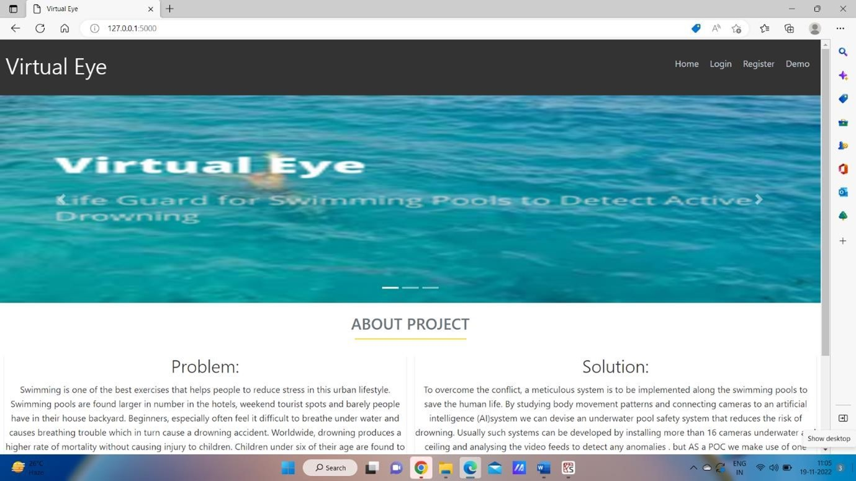

**Case2:** Register page

We can register into the account using this page, by using our credentials we can register our account in the application.

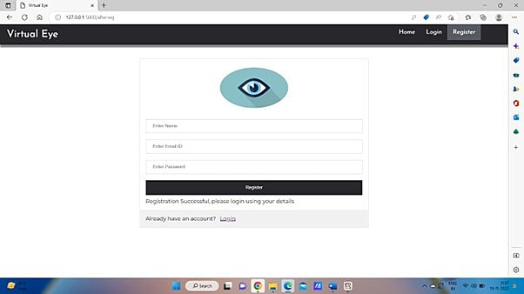

**Case3:** Login page

In this page with the credentials we used to register we can login into our account to try the demo of our project

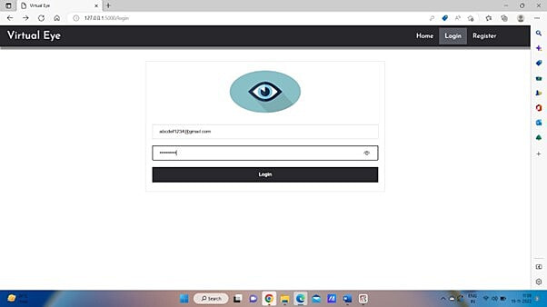

**Case4:** Prediction page

This page helps in showcasing our demo of the project. On clicking the button for demo we can get the results in the project.

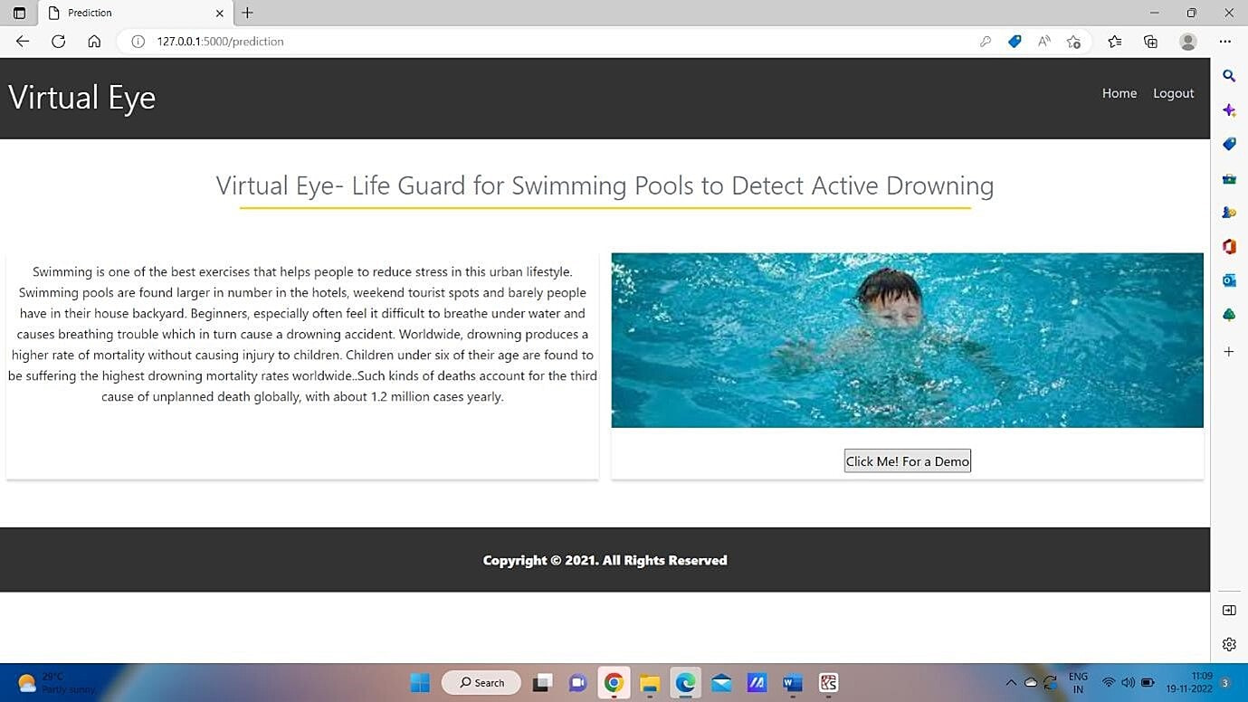

**Case5:** Logout page

In this page we can come out of our application by safely logging off our account.

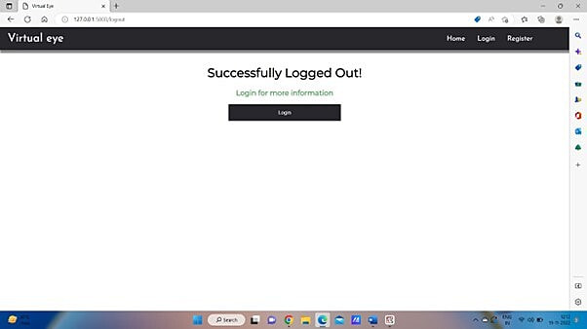

# 8.TESTING

## 8.1 Test Cases

This report shows the number of test cases that have passed, failed, and untested

|  |  |  |  |  |  |
| --- | --- | --- | --- | --- | --- |
| **Section** | **Total Cases** | **Not**  **Tested** | **Fai**  **l** | **Pass** |  |
| Print Engine | 10 | 0 | 0 |  | 10 |
| Client Application | 15 | 0 | 0 |  | 15 |
| Security | 2 | 0 | 0 |  | 2 |
| Outsource Shipping | 0 | 0 | 0 |  | 0 |

## 8.2 User Acceptance testing

**Defect Analysis**

This report shows the number of resolved or closed bugs at each severity level, and how they were resolved

|  |  |  |  |  |  |
| --- | --- | --- | --- | --- | --- |
| **Resolution** | **Severity 1** | **Severity 2** | **Severity 3** | **Severity 4** | **Subtotal** |
| By Design | 4 | 5 | 1 | 2 | 12 |
| Duplicate | 2 | 0 | 2 | 0 | 3 |
| External | 4 | 3 | 1 | 1 | 9 |
| Fixed | 15 | 4 | 3 | 23 | 45 |
| Not Reproduced | 0 | 0 | 0 | 0 | 0 |
| Skipped | 0 | 0 | 0 | 0 | 0 |
| Won't Fix | 0 | 1 | 0 | 0 | 1 |
| Totals | 25 | 13 | 7 | 26 | 70 |

**9. RESULTS**

**9.1 Performance Metrics**

**Velocity:**

Imagine wehave a 10-day sprint duration,and the velocity of the team is 20 (pointsper sprint). Let’s calculate the team’s averagevelocity (AV) per iteration unit (story pointsper day)

Sprint-1 the Average Velocity (AV) is:AV = Sprint Duration / velocity = 8 / 6 = 1.3V For

Sprint-2 the Average Velocity(AV) is: AV = Sprint Duration / velocity = 14 / 6 = 2.3VFor

Sprint-3 the Average Velocity(AV) is: AV = Sprint Duration / velocity = 16 / 6 = 2.6VFor

Sprint-4 the Average Velocity (AV) is: AV = Sprint Duration / velocity = 12/ 6 = 2.0V

TOTAL TEAM AVERAGE VELOCITY = 2.08

**10. ADVANTAGES**

It represents an additional level of safety and protection for swimmers. It ensures effective and reliable drowning detection by limiting the number of alarms generated by disturbance factors. Prevents drowning accidents by improving the rescue time of the lifeguards.

**DISADVANTAGES**

A limitation of this equipment is that if too many swimmers, the occlusion problem arises. The other is that the camera is mounted upon the water, and monitors the Swimmer posture change.

**11. CONCLUSION**

Once we have the working drowning detection model we can feed live video footage of the swimming pool to it so that it can keep detecting continuously for any drowning activities. If drowning is detected it will be highlighted on the system screen as well as alarms will be raised to alert security guards so that they can initiate rescue

**12. FUTURE SCOPE**

The global anti-drowning system market size was valued at USD 67.68 million in 2021. It is projected to reach USD 98.86 million by 2030, growing at a CAGR of 4.3% during the forecast period (2022-2030). The residential segment by application is estimated to grow at a CAGR of 3.9% during the forecast period.

**13. APPENDIX**

**HTML:**

<https://github.com/IBM-EPBL/IBM-Project-48286-1660806279/blob/main/application%20building/BUILT%20HTML%20PAGE.pdf>

**PYTHON:**

<https://github.com/IBM-EPBL/IBM-Project-48286-1660806279/blob/main/application%20building/Build%20Python%20code%20(1).pdf>

**SourceCode:**

<https://github.com/IBM-EPBL/IBM-Project-48286-1660806279/tree/main/Project%20Development%20Phase>